MATH4U – MATH IN FOUR LANGUAGES
FOR STUDENTS AND TEACHERS
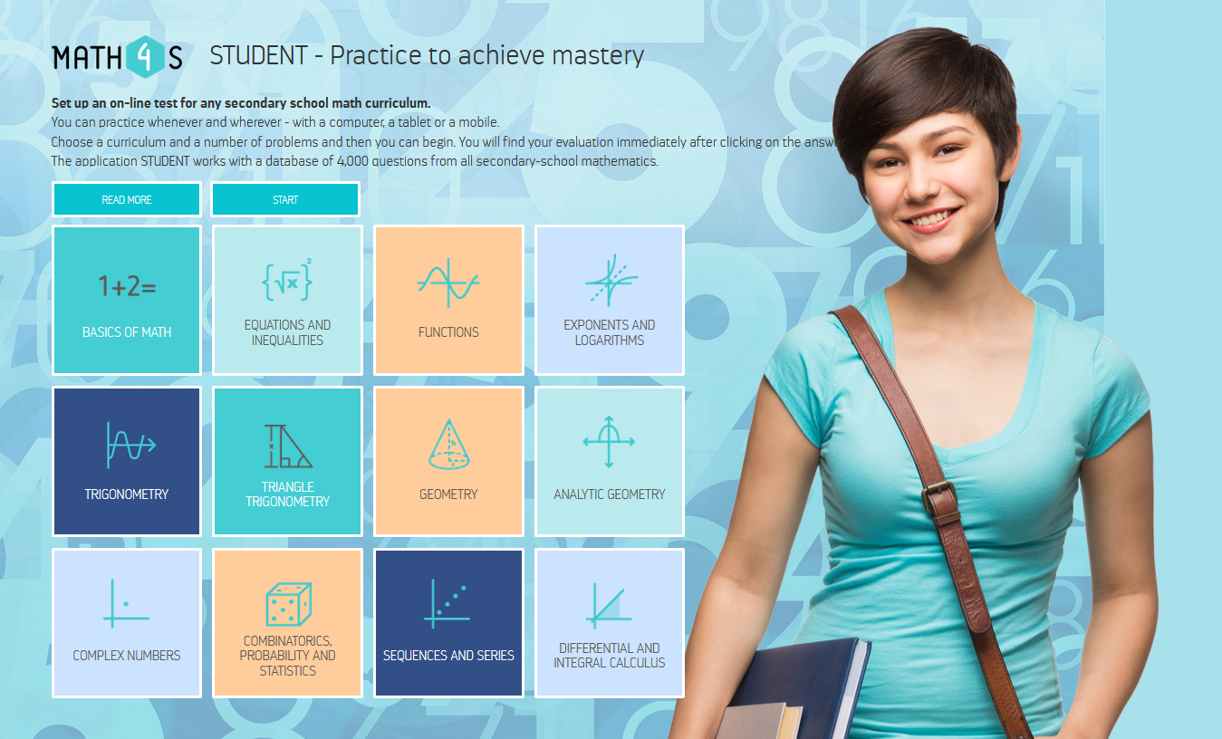

New educational portal Math Exercises for You (Math4U) offers attractive and complex training materials for students and also offers tools for teachers to prepare tests and exams.
Math4U portal is divided into three main sections - Math for Student (Math4S), Math for Teacher (Math4T) and Math for Class (Math4C).
What is common for all three parts of website? Firstly, all secondary math curriculum is divided to 12 topics. Secondly, all parts of portal and all applications are available in four languages - English, Czech, Slovak and Polish.

Math for Student
This is the place where students find unique educational software for practicing all areas of secondary school mathematics.
- A student chooses a language, a topic, a subtopic, a level and a number of questions.
- The software generates an interactive HTML test according to his or her preferences.
- The student receives partial feedback after answering each question and final evaluation after finishing the whole test.
- The Math4S software works with database of 16,000 questions in four languages.
Student can:
- Practice wherever and whenever – with a computer, tablet or smartphone.
- Choose a customized practice – practice a particular subtopic exactly when he/she is learning it at school.
- Choose a summary practice – before the state leaving examination.
- Choose a number of questions – according to his or her time.
- Switch languages – practice his/her math English. The student can choose the language for a particular test and this chosen language can be changed at any time when working with the test. This also greatly contributes to broadening and deepening the knowledge of mathematical English.

Math for Teacher
A teacher can prepare a tailor-made interactive test or written test. The creating the test is of the same difficulty as a shopping in e-shop. Teacher chooses any questions he or she likes from the database of 4,000 questions in each of the four languages (English, Czech, Slovak and Polish), which is about 16,000 questions in total, and put them into a “shopping cart”. Then interactive test or printer ready version of written test is generated from a “shopping cart”.
Every tests are in PDF format and can be used off-line. After finishing the interactive test, the students can go through all the questions again and revise the answers. The order of the answers can be randomized when the test is reopened.
The teacher can:
- Create a test according to a topic and subtopic or to the knowledge of his/her students,
- Create the same test in different languages. This can be useful in case of bilingual schools or for exchange students in a class. It is also a great opportunity to improve language skills when preparing for international math competitions or when preparing to study abroad.
- Use a test with the whole class for the revision of the previous topic.
- Use a test with the whole class for practicing the just discussed topic.
- Use a test for creating fun, a competitive atmosphere in the class.
- Publish the test on his/her website – give it as homework.
Teacher’s account is required in this part of website. All tests generated by the teacher are stored within his/her account.

Math for Class
In the section Math4C, students and teachers can find 150 interesting quizzes and educational games so called “matching game” and “table-selection game”. All games are in PDF format.

Matching games
- Mainly, the aim of these games is to match the questions with the correct answers.
- Step by step, the player selects questions and answers and builds correct pairs of a question and a matching answer. It doesn´t matter in which order the player selects the questions.
- When matching the question with an incorrect answer, the player continues in the game with one penalty point.
- Incorrect attempts are recorded and shown at the end of the game.
- When all pairs are established, the student can see the number of incorrect attempts taken with an informal comment and a picture which express evaluation of the result.
- Each correctly build question-answer pair in a matching game uncovers a part of a hidden quotation of a famous mathematician. A page of interesting notes from the life of the author is shown after clicking the name.

Table-selection games
The table-selection game is designed to practice basic math skills such as converting degrees to radians, evaluating angles in triangle, performing complex number operations, expanding expressions, and many more.
- Aim is to choose all the correct answers.
- Answers are organized in a table.
- After finishing you can see your number of incorrect attempts, a funny comment and a picture.

Portal math4u.vsb.cz is completely free of charge.

